**Lab 6 Routing**

**LAB 6.1: Understanding and configuring Static Routing by using Packet Tracer.**

**Objective:** To perform Static Routing operation on the network and observe the network behavior using static routing.

**Devices used**

|  |  |  |  |
| --- | --- | --- | --- |
| **S.N.** | **Device** | **Model** | **Quantity** |
| 1 | PC | PC | 4 |
| 2 | Switch | PT-Switch | 2 |
| 3 | Router | PT-Router | 2 |
| 4 | Cable | Straight through | 6 |
| 5 | Cable | Serial DEC | 1 |

**Background**

Static routes are the routes you manually add to the router’s routing table. The process of adding static routes to the routing table is known as static routing.

**Topology**

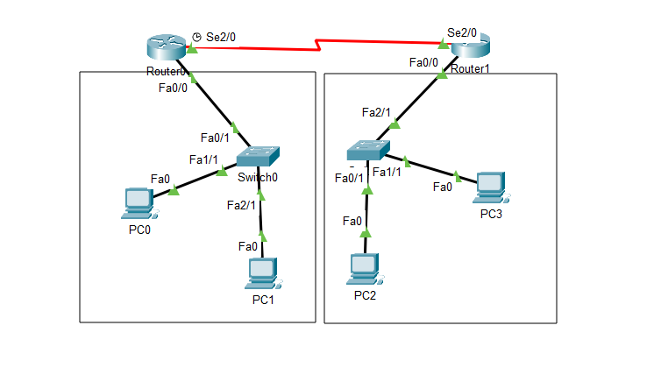

**IP Address Plan**

|  |  |  |  |  |  |
| --- | --- | --- | --- | --- | --- |
| **Device** | **Interface** | **IP** | **Subnet Mask** | **VLAN** | **Default gateway** |
| PC0 | NIC | 192.168.10.2 | 255.255.255.0 | Default | 192.186.10.1 |
| PC1 | NIC | 192.168.10.3 | 255.255.255.0 | Default | 192.168.10.1 |
| PC2 | NIC | 192.168.20.2 | 255.255.255.0 | Default | 192.168.20.1 |
| PC3 | NIC | 192.168.20.3 | 255.255.255.0 | Default | 192.168.20.1 |
| Router 0 | Fa 0/0 | 192.168.10.1 | 255.255.255.0 | Default | - |
| Router 0 | Se 2/0 | 11.0.0.1 | 255.255.255.0 | Default | - |
| Router 1 | Fa 0/0 | 192.168.20.1 | 255.255.255.0 | Default | - |
| Router 1 | Se 2/0 | 11.0.0.2 | 255.255.255.0 | Default | - |

**Procedure**

1. Routers are joined together with Serial DCE wires
2. Switches are joined with each router individually
3. 2 PCs are joined with each switches
4. Set IP and Default gateway in each PC
5. Set the IP addresses in the routers interfaces

In Router 0:

Router(config-if)#ip address 192.168.10.1 255.255.255.0

Router(config-if)#ip address 11.0.0.1 255.255.255.0

In Router 1:

Router(config-if)#ip address 192.168.20.1 255.255.255.0

Router(config-if)#ip address 11.0.0.2 255.255.255.0

1. Set Static routes

Static path setting in Router 0: Router(config)# ip route 192.168.20.0 255.255.255.0 11.0.0.2

Static Path Setting in Router 1: Router(config)# ip route192.168.10.0 255.255.255.0 11.0.0.1

**Verification**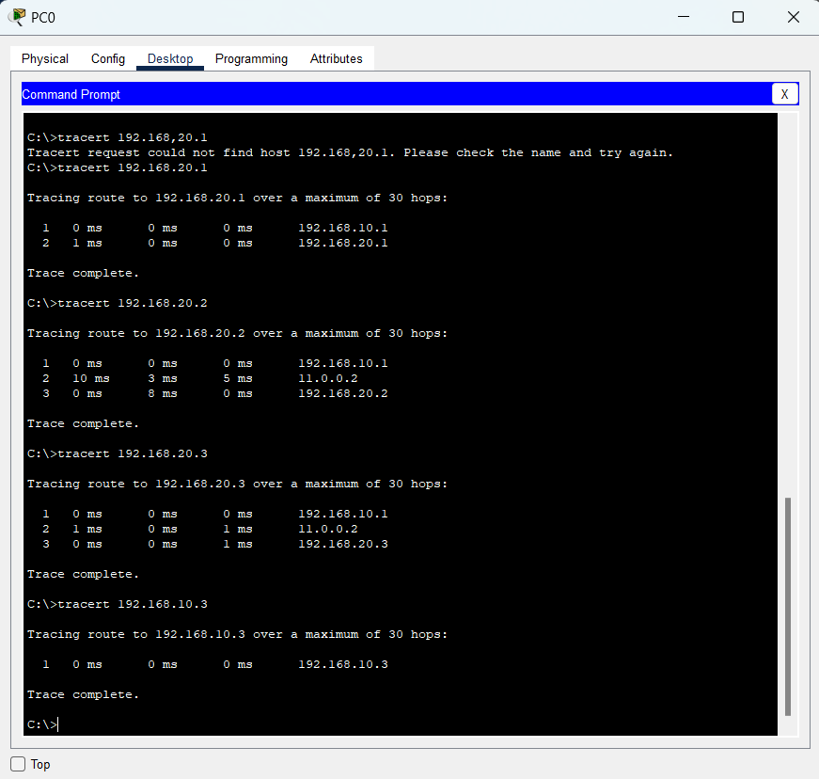

**Conclusion:** In this experiment, static routing is done successfully and shows that static routes are fixed and do not change automatically. It changes only if the administrator changes.

# LAB 6.2: Understanding and configuring Routing Information Protocol (RIP) by using Packet Tracer.

**Objective:** To understand and illustrate the dynamic routing protocol RIP by using Packet Tracer.

**Background**

Routing Information Protocol (RIP) is a dynamic routing protocol which uses hop count as a routing metric to find the best path between the source and the destination network.

RIP is one of the oldest dynamic routing protocols

**Devices used**

|  |  |  |  |
| --- | --- | --- | --- |
| **S.N.** | **Device** | **Model** | **Quantity** |
| 1 | PC | PC | 6 |
| 2 | Switch | PT-Switch | 3 |
| 3 | Router | PT-Router | 3 |
| 4 | Cable | Straight through | 9 |
| 5 | Cable | Serial DEC | 2 |

**Topology**

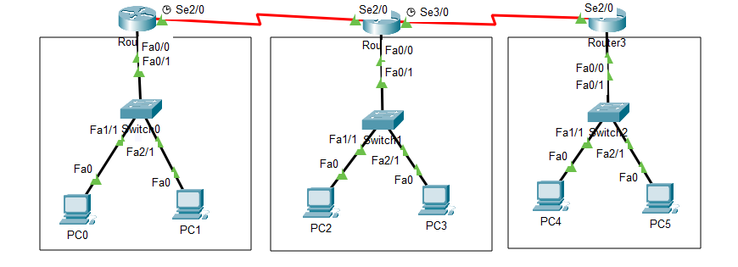

**IP Address Plan**

|  |  |  |  |  |  |
| --- | --- | --- | --- | --- | --- |
| **Device** | **Interface** | **IP** | **Subnet Mask** | **VLAN** | **Default gateway** |
| PC0 | NIC | 192.168.10.2 | 255.255.255.0 | Default | 192.186.10.1 |
| PC1 | NIC | 192.168.10.3 | 255.255.255.0 | Default | 192.168.10.1 |
| PC2 | NIC | 192.168.20.2 | 255.255.255.0 | Default | 192.168.20.1 |
| PC3 | NIC | 192.168.20.3 | 255.255.255.0 | Default | 192.168.20.1 |
| PC4 | NIC | 192.168.30.2 | 255.255.255.0 | Default | 192.168.30.1 |
| PC5 | NIC | 192.168.30.3 | 255.255.255.0 | Default | 192.168.30.1 |
| Router 0 | Fa 0/0 | 192.168.10.1 | 255.255.255.0 | Default | - |
| Router 0 | Se 2/0 | 10.0.0.1 | 255.255.255.0 | Default | - |
| Router 1 | Fa 0/0 | 192.168.20.1 | 255.255.255.0 | Default | - |
| Router 1 | Se 2/0 | 10.0.0.2 | 255.255.255.0 | Default | - |
| Router 1 | Se 3/0 | 11.0.0.1 | 255.255.255.0 | Default | - |
| Router 3 | Fa 0/0 | 192.168.30.1 | 255.255.255.0 | Default | - |
| Router 3 | Se 2/0 | 11.0.0.2 | 255.255.255.0 | Default | - |

**Procedure**

1. Routers are joined together with Serial DCE wires
2. Switches are joined with each router individually
3. 2 PCs are joined with each switches
4. Set IP and Default gateway in each PC
5. Set the IP addresses in the routers Interfaces as shown in the IP address plan table
6. Perform the following setup to illustrate dynamic routing using RIP

In router 0:

Router(config)#router rip

Router(config)#network 192.168.10.0

Router(config)#network 10.0.0.0

In router 1:

Router(config)#router rip

Router(config)#network 192.168.20.0

Router(config)#network 10.0.0.0

Router(config)#network 11.0.0.0

In router 2:

Router(config)#router rip

Router(config)#network 192.168.30.0

Router(config)#network 11.0.0.0

**Verification**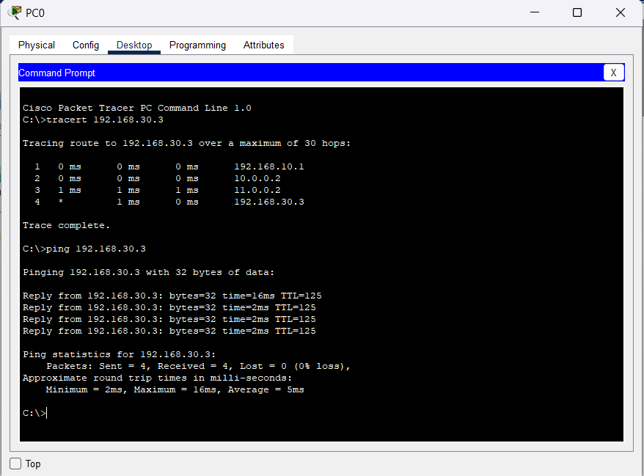

**Conclusion**

In this experiment, Routing Information Protocol (RIP) routing is done successfully and shows that RIP routes are not fixed and change automatically according to routing information that received from neighbor router to find the best path between the source and the destination network.

**LAB 6.3: Understanding and configuring Open Shortest Path First (OSPF) by using Packet Tracer.**

**Objective:** To configure and understand the OSPF as a dynamic routing protocol.

**Background**

Open Shortest Path First (OSPF) is a link-state routing protocol that was developed for IP networks and is based on the Shortest Path First (SPF) algorithm.

**Devices used**

|  |  |  |  |
| --- | --- | --- | --- |
| **S.N.** | **Device** | **Model** | **Quantity** |
| 1 | PC | PC | 3 |
| 2 | Switch | PT-Switch | 3 |
| 3 | Router | PT-Router | 3 |
| 4 | Cable | Straight through | 6 |
| 5 | Cable | Serial DEC | 3 |

**Topology**

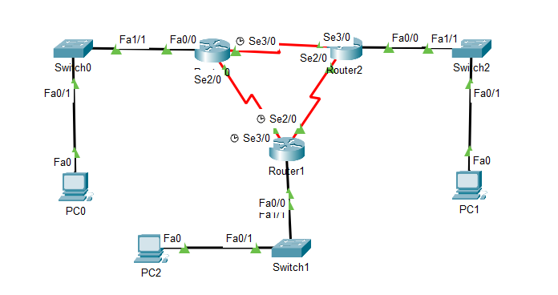

**IP Address Plan**

|  |  |  |  |  |  |
| --- | --- | --- | --- | --- | --- |
| **Device** | **Interface** | **IP** | **Subnet Mask** | **VLAN** | **Default gateway** |
| PC0 | NIC | 192.168.10.2 | 255.255.255.0 | Default | 192.186.10.1 |
| PC1 | NIC | 192.168.30.2 | 255.255.255.0 | Default | 192.168.30.1 |
| PC2 | NIC | 192.168.20.2 | 255.255.255.0 | Default | 192.168.20.1 |
| Router 0 | Fa 0/0 | 192.168.10.1 | 255.255.255.0 | Default | - |
| Router 0 | Se 2/0 | 192.168.150.1 | 255.255.255.0 | Default | - |
| Router 0 | Se 3/0 | 192.168.200.1 | 255.255.255.0 | Default | - |
| Router 1 | Fa 0/0 | 192.168.20.1 | 255.255.255.0 | Default | - |
| Router 1 | Se 2/0 | 192.168.100.2 | 255.255.255.0 | Default | - |
| Router 1 | Se 3/0 | 192.168.150.2 | 255.255.255.0 | Default | - |
| Router 3 | Fa 0/0 | 192.168.30.1 | 255.255.255.0 | Default | - |
| Router 3 | Se 2/0 | 192.168.100.2 | 255.255.255.0 | Default | - |
| Router 3 | Se 2/0 | 192.168.200.2 | 255.255.255.0 | Default | - |

**Procedure**

1. Routers were joined together with Serial DCE wires
2. Switches were joined with each router individually
3. 2 PCs were joined with each switches
4. Set IP and Default gateway in each PC as shown in the IP address plan table
5. Performed the following setup to configure OSPF in each router

In router 0:

Router(config)#router ospf 1

Router (config-router)#network 192.168.100.0 0.0.0.255 area 0

Router (config-router)#network 192.168.150.0 0.0.0.255 area 0

Router (config-router)#network 192.168.20.0 0.255.255.255 area 0

In router 1:

Router(config)#router ospf 1

Router (config-router)#network 192.168.200.0 0.0.0.255 area 0

Router (config-router)#network 192.168.150.0 0.0.0.255 area 0

Router (config-router)#network 192.168.10.0 0.255.255.255 area 0

In router 2:

Router(config)#router ospf 1

Router (config-router)#network 192.168.200.0 0.0.0.255 area 0

Router (config-router)#network 192.168.100.0 0.0.0.255 area 0

Router (config-router)#network 192.168.30.0 0.255.255.255 area 0

**Verification**

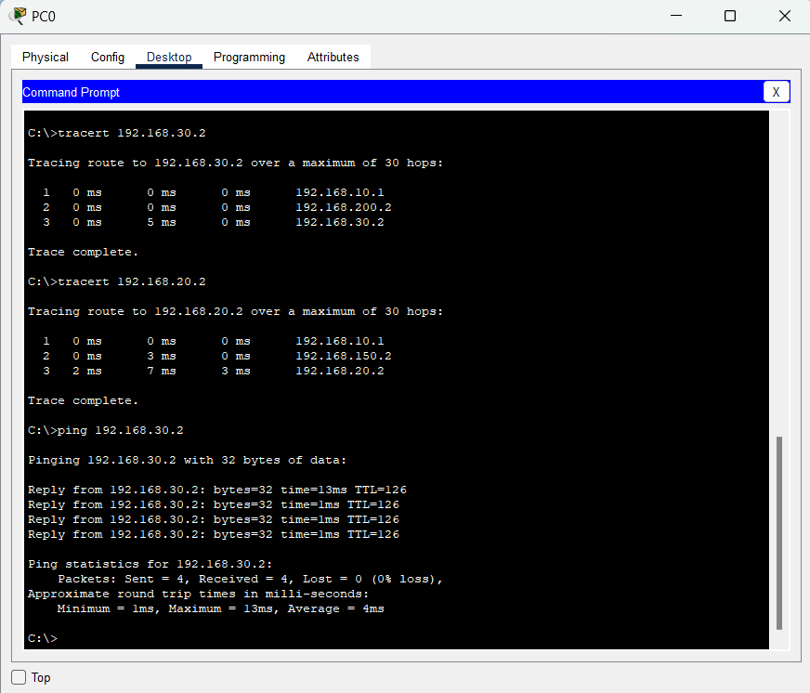

**Conclusion**

OSPF has been successfully configured and helps to find the shortest path from sender to receiver as shown in verification.

**LAB 6.4: Understanding and configuring Broder Gateway Protocol (BGP) by using Packet Tracer.**

**Objective:** To configure and understand the BGF by using Packet Tracer.

**Background**

BGP is the latest routing protocol of the Internet, which is classified as a DPVP (distance path vector protocol). It sends updated router table data when changes are made.

**Devices used**

|  |  |  |  |
| --- | --- | --- | --- |
| **S.N.** | **Device** | **Model** | **Quantity** |
| 1 | PC | PC | 2 |
| 2 | Switch | PT-Switch | 2 |
| 3 | Router | PT-Router | 2 |
| 4 | Cable | Straight through | 2 |
| 5 | Cable | Serial DEC | 2 |

**Topology**

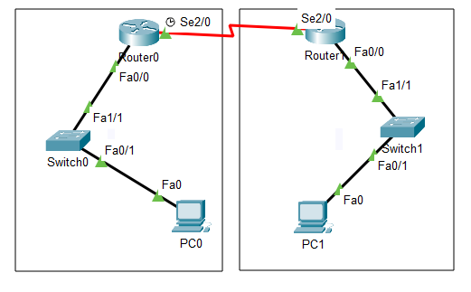

**IP Address Plan**

|  |  |  |  |  |  |
| --- | --- | --- | --- | --- | --- |
| **Device** | **Interface** | **IP** | **Subnet Mask** | **VLAN** | **Default gateway** |
| PC0 | NIC | 192.168.2.2 | 255.255.255.0 | Default | 192.186.2.1 |
| PC1 | NIC | 192.168.3.2 | 255.255.255.0 | Default | 192.168.3.1 |
| Router 0 | Fa 0/0 | 192.168.2.1 | 255.255.255.0 | Default | - |
| Router 0 | Se 2/0 | 192.168.1.1 | 255.255.255.0 | Default | - |
| Router 1 | Fa 0/0 | 192.168.3.1 | 255.255.255.0 | Default | - |
| Router 1 | Se 2/0 | 192.168.1.2 | 255.255.255.0 | Default | - |

**Procedure**

1. Routers were joined together with Serial DCE wires
2. Switches were joined with each router individually
3. A PC was joined with each switches
4. Set IP and Default gateway in each PC as shown in the IP address plan table
5. Performed the following setup to configure BGP in each router

In Router 0:

Router(config)#router bgp 1

Router(config-router)#network 192.168.1.0

Rounetwork 192.168.1.0network 192.168.2.0

Router(config-router)#neighbor 192.168.1.2 remote-as 2

Router(config-router)#neighbor 192.168.3.2 remote-as 2

In Router 1:

Router(config)#router bgp 2

Router(config-router)#network 192.168.1.0

Router(config-router)#network 192.168.2.0

Router(config-router)#neighbor 192.168.1.1 remote-as 1

Router(config-router)#neighbor 192.168.2.3 remote-as 1

**Verification**

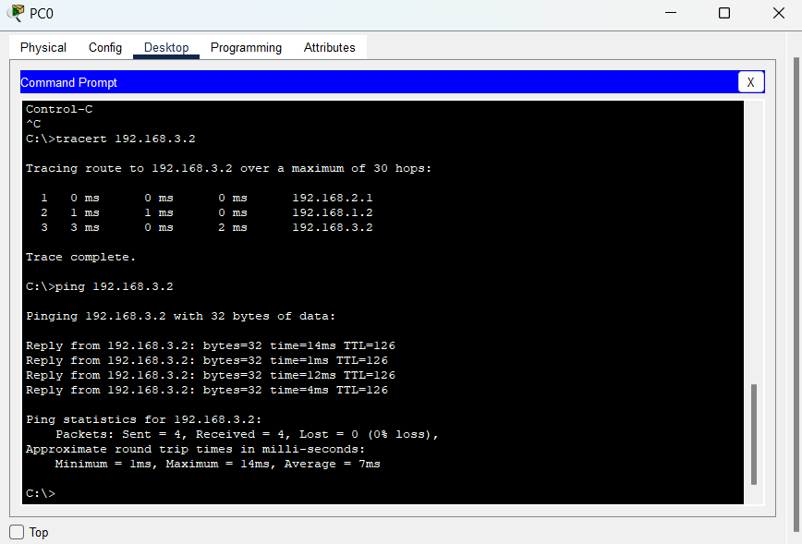

**Conclusion**

BGP has been successfully configured and found that there is no auto-discovery of topology changes, so the user needs to configure BGP manually.